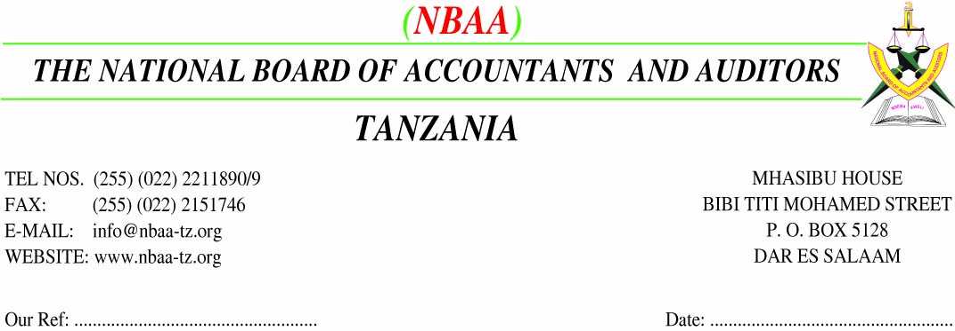

**EAST AFRICA CONGRESS OF ACCOUNTANTS AT AICC - ARUSHA FROM 5th TO 7TH MARCH 2015**

**DELEGATE REGISTRATION FORM**

**ORGANISATIONS’ DETAILS**

|  |  |
| --- | --- |
| **NAME OF ORGANISATION** |  |
| **COUNTRY** |  |
| **POSTAL ADDRESS** |  |
| **TELEPHONE** |  |
| **FAX** |  |
| **EMAIL** |  |

**DELEGATE (S) INFORMATION**

|  |  |  |
| --- | --- | --- |
| **1** | **FIRST NAME** |  |
| 2 | **MIDDLE NAME** |  |
| 3 | **SURNAMNE** |  |
| 4 | **GENDER** | MALE/FEMALE |
| **4.** | **TELEPHONE** |  |
| **5.** | **EMAIL ADDRESS** |  |
| **5** | **INSTITUTE REGISTERED WITH** |  |
| **5.** | **REGISTRATION NUMBER** |  |

**CONCURENT SESSIONS/PLEASES INDICATE YOUR OPTION**

**TRACK 1 /TRACK 2**

**DELEGATE(S)**

SIGNATURE...................................................................DATE............................................................

I hereby confirm my attendance to the conference indicated and I accept the terms and conditions specified.

**PERSON/ORGANISATION RESPONSIBLE FOR PAYMENT**

………………………………………………………………………………………………………………………………………………

SIGNED AT..............................................ON THIS .................................DAY OF........................................2015

SIGNATURE...................................................................DESIGNATION..............................................................

I hereby confirm that arrangements for payment for the above mentioned conference delegates are in place, and agree

to the payment procedures as outlined by the institution/organization.

**CONFERENCE FEES**

**Conference Fees per delegate:**

**Tshs.700,000/= or USD 400**

**HOW TO REGISTER**

**Please complete the form,**

**and fax to +255 222151746 or scan**

**and email it to** [**e**](mailto:dan@panafricant.com)**acoaregistration@nbaa-tz.org**

**Attention: Mr.Angyelile Tende**

**BANKING DETAILS**

**For TZS**

**NATIONAL BOARD OF ACCOUNTANTS AND AUDITORS**

**CRDB BANK PLC**

**VIJANA BRANCH**

**ACCOUNT No: 01J1005553500**

**SWIFT CODE: CORUTZTZ**

**For USD**

**STANDARD CHARTERED BANK TANZANIA**

**INTERNATIONAL HOUSE BRACH**

**ACCOUNT No.8702020497700**

**SWIFT CODE: SCBLTZTZ**